**IOT - SMART WASTE MANAGEMENT SYSTEM**

INTRODUCTION

The Internet of Things (IoT) is a concept in which surrounding objects are connected through wired and wireless networks without user intervention. In the field of IoT, the objects communicate and exchange information to provide advanced intelligent services for users.

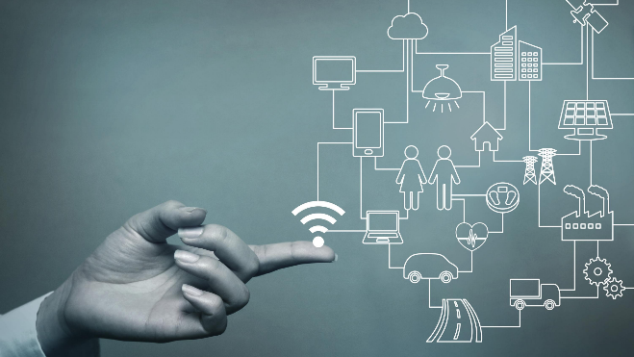

This project deals with the problem of waste management in metropolitan cities, where the garbage collection system is not optimized. This project enables the organizations to meet their needs of smart waste management systems. This system allows the user to know the fill level of each garbage bin in a locality or city at all times to enhance the atmosphere.

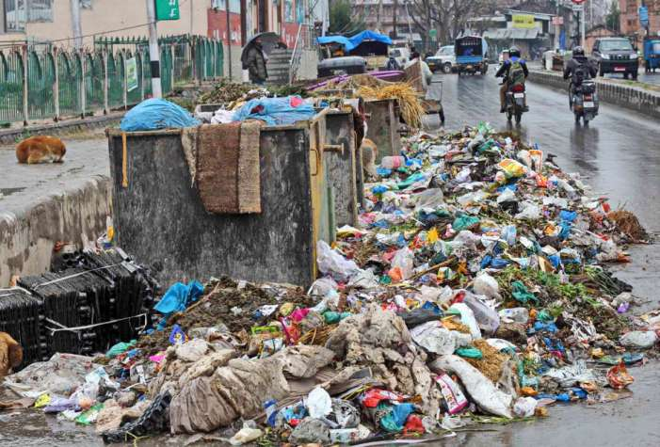

OBJECTIVES

The key research objectives for the proprosed system are as follows:

* It would be able to automate the solid waste monitoring process and management of the overall collection process using IOT (Internet of Things).
* It consists of main subsystems namely Smart Trash System(STS) and Smart Monitoring and Controlling Hut(SMCH).
* In the proposed system, whenever the waste bin crosses the first fixed limit, it automates a message acknowledged by placing the circuit at the waste bin, which transmits it to the receiver at the desired place in the regional area .
* The received signal indicates the waste bin status at the monitoring and controlling system.
* If the bin crosses the second fixed limit, it automatically closes the trash bin and the supplementary bin can be accessed for additional waste.
* The trash bin location is intimated to the truck driver to collect the trash and clean the bin
* If the bin is cleared by the driver, then the message is intimated to the regional area.

PRODUCT FEATURES

With the GPS tracker and details, the administrator will be able to search for dustbins. The result will be based on the criteria the user inputs. There are several search criteria, and it will be possible for the administrator of the system to manage the options for those criteria that have that.

The result of the search will be viewed either in a list view or in a map view, depending on what criteria are included in the search. The list view will have one list item for each dustbin matching the search criteria and show a small part of the dustbin information, so the user can identify the dustbin.

The administrator will be able to either select a dustbin as a target destination or get information on how to get there or view the information of a specific dustbin.

The web portal will provide the functionality to manage the system and the dustbin information. It will also provide information about the system, for example, showing when there is a new update.

A list of possible stakeholders of the system and a brief description of their needs, business rules, possibilities and connections with others is presented below:

• City administration needs an understanding of the big picture, generating reports, control over pricing etc.

• District administrations are interested in controlling the process of waste collection, checking the quality of service (all waste collected, all in time, waste collected cleanly, waste transported to special places), quick and legal ways for solving disputes and problems.

• Municipalities can also deploy and maintain smart city infrastructure like capacity sensors in waste bins and wireless networks for data transferring.

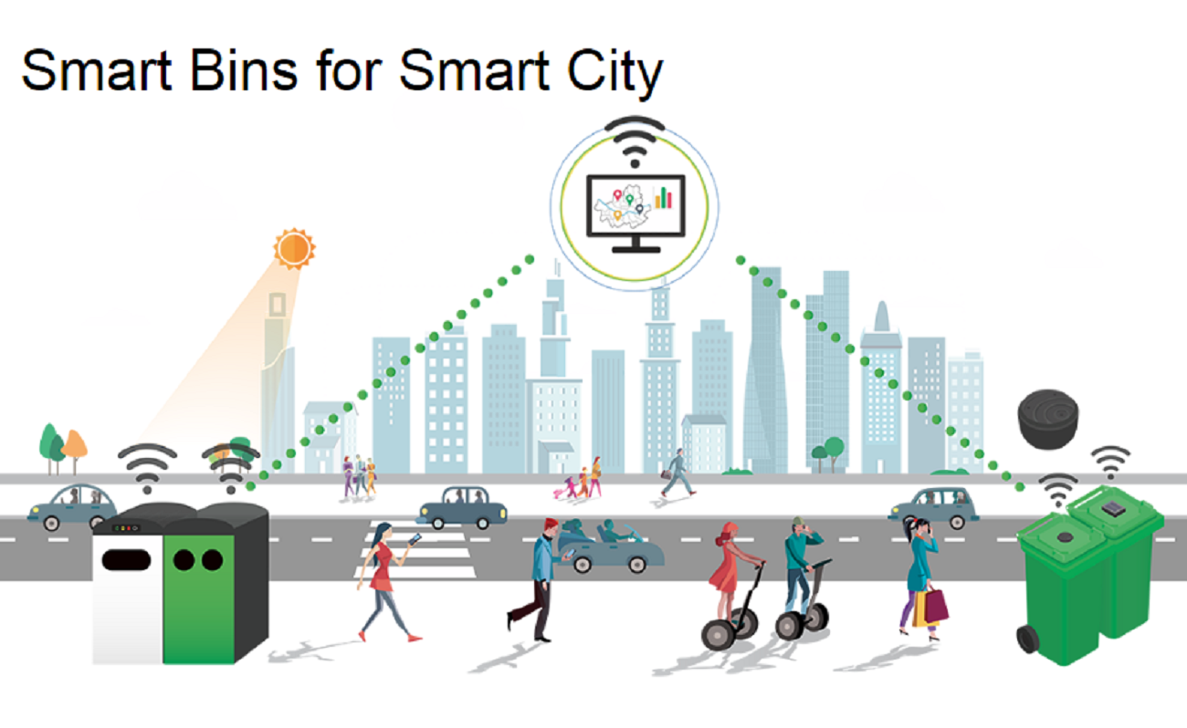

• Waste trucks owning companies need a platform for organizing and optimization of their business process in general without serious investments in developing, deploying and supporting their own system. Such a system must include effective dynamic routing based on IOT data for the truck fleet. Besides, controlling drivers and tracking the fleet is also an important issue.

• Waste truck drivers need a navigation system for fulfilling their tasks. Another issue is reporting problems and passing them to the operators in the office instead of thinking about how to solve the problem, this can sufficiently save the time of a driver and vehicle. Drivers also need evidence that their work was done correctly and cleanly.

• Managers of dumps and recycling factories can publish their possibilities or needs in acquiring a certain amount of waste for storing or recycling.

• Staff that is responsible for trash bins in the current yards needs communications with waste management companies and truck drivers.

• Road police can get reports about inaccurate car parking that leads to the impossibility of waste collection. • Citizens want to have better service, lower cost and having easily accessible reports on what has been done and how much it cost

Application

The project design is a part of the implication that can be used to improve the waste management of a locality. All the technical aspects have been thoroughly designed keeping all the constraints in mind. The project resolves around whether the project will be able to meet the future needs of the users. This project-based on IoT gives users the freedom of changing hardware as well as software specifications as per the arising need. IoT based projects are already designed while keeping future demands in mind and in a rising economy like India where the concept of smart cities is new the demand for our project will keep on increasing. This project here is a model of the large scale application which spans pan India in different smart cities. The implementation of this project has been divided into various phases. Starting from the metropolitan cities and moving towards the concept of smart cities, it will also cover small towns and tier III cities in later phases. At present, we are here to display the live working of the model and give an idea about the actual implications. For any society to flourish, it is manifestly important that they remain fair and orderly. Deciding how best to ensure this, in light of the huge growth in both the uptake and complexity of technology that has occurred in the last decade, and which can be expected to continue in the next, this here is one of the products that can be used to contribute to the better management of waste and increase the efficiency of resources.